Autodesk ReCap 2014

Autodesk® ReCap™ is a family of software and services to create intelligent 3D data from captured photos and laser scans. Autodesk ReCap delivers a powerful and easy to use workflow on the desktop and in the cloud to create intelligent 3D data from laser scans and captured photos. Seamlessly integrated with Autodesk Design and Creation suites, Autodesk ReCap Studio makes it easy to clean, organize and visualize massive datasets captured from reality. Autodesk ReCap Photo helps users create high-resolution textured 3D models from photos using the power of cloud computing. Rather than beginning with a blank screen, Autodesk ReCap now enables any designer, architect or engineer to add, modify, validate and document their design process in context from existing environments.

Autodesk ReCap Product Line

ReCap Studio
- Desktop application, data preparation environment
- QA and verification of data
- Direct import into Autodesk design solutions
- From non-intelligent, black and white sparse point cloud, to intelligent, visually high appealing content
- Shipping in Product & Suites Installers
- Available on Autodesk Exchange Apps store

ReCap Photo
- Autodesk 360 service, create high resolution 3D data from photos
- Visualize and share 3D data
- Leverage cloud processing and storage
- Uploading your images on Autodesk 360 and creating a 3D mesh model from them
- Available with Standard Suites entitlement and up

In addition to the Suites, Autodesk ReCap will ship as part of the following 2014 products:

AutoCAD AutoCAD Civil 3D Autodesk Map 3D
Autodesk Plant 3D Autodesk Navisworks Autodesk Revit
Autodesk Inventor Autodesk 3ds Max Autodesk Infraworks

Key features of Autodesk ReCap include:

- Simple Collaboration and Viewing: On the desktop, users can view and publish scans to their secure Autodesk 360 account for viewing, sharing and collaboration. The simple, lightweight cloud-based viewing enables in-field mobile viewing, measuring and collaboration.
- Professional-Grade Photo to 3D Features: ReCap unlocks the power of ubiquitous cameras to capture high-quality 3D models, bringing reality capture within reach of anyone with a camera. ReCap supports objects of any size and range, full-resolution for high-density meshes, survey points and multiple file exports.
- Photo and Laser: ReCap incorporates both photo and laser data capture so that customers can use photos to fill in holes or augment laser scan data. And vice versa, users can increase photos’ scene accuracy with laser points and add photo-realistic detail to laser scans. Create point clouds from photos, align scans and photos and convert professional grade photo to 3D models.

Why Autodesk ReCap?

- Superior Collection Capabilities
  - 50% to 75% reduction of in-field data collection
  - Hard ROI: lower deployment cost, increased capacity
  - Lower risk of collection error
- Competitive Differences
  - Only solution combining both photo and laser data capture
  - Visualization Quality
  - Scalability – able to handle larger data sets than anyone else
  - Integrated with Autodesk products
- Competitive Bidding
  - Same deliverables/lower costs – or – better deliverables/same cost
- Streamlined Operations
  - Mandated documentation (Oil & Gas, Transportation, Architecture)
  - Facility planning (Factory, Plant)
  - Low impact retrofit (Factory)

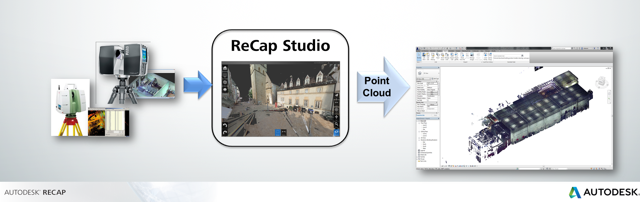

ReCap makes working with Reality Capture data easy, quick and cost effective.

